### **Study and Test Structure**

The model involves 10 lists, each consisting of 20 study and 20 recognition test trials with picture stimuli. Within each list, contextual and content features play a role in recognition decisions.

### **Context Representation and Change Mechanisms**

Each list (ℓ: 1-10) includes both changing context CC_ℓ and unchanging context UC. There are 75 features in total, divided into:

* 25 changing context features CC_ℓ, which each feature changes between lists with probability [δ_list]=0.14.
* 25 unchanging context features UC, which remain stable across lists.
* 25 content features C, which are tied to the studied items themselves.

Within each list, **context (both change and unchange) undergoes** a drift between study and test with probability [δ_drift]=0.14, followed by reinstatement to the study context after each test with probability [δ_reinstate]=0.4 (this equal about 92% were all reinstated back to study features after 5 lists).

### **Feature Encoding and Storage Probability**

* The geometric base rate for words is [g_word = 0.4].
* The geometric base rate for context is [g_context = 0.3].
* The probability of storage **of context** [U_star] is special for first list and first test in each list:
  + In the first list, all studied items have a 0.08 storage probability.
  + All subsequent lists have a 0.04 storage probability (except first test)
  + The first item of the first test in the first list has a 0.1 storage probability.
  + The first item in the first test of all subsequent lists has a 0.08 storage probability.
* The copying parameter [C] is 0.8 across all lists, study trials, and test trials.

### **Memory Update During Testing (Restorage)**

The model assumes both strengthening of existing traces and addition of new traces during recognition testing:

* Strengthening applies **only to content features**, not context features.
* When an old item is judged, the maximum likelihood trace is retrieved, and each content feature is compared with the probe.
* Blank (0) and mismatched content features have a probability of being restored.
* When a new item is judged, a new trace is formed, where the probe's content and content features go through the same storage process as in study.
* **Perfect storage of target**: Item that is tested as target is assumed to be stored better than foils (prob storage 1 for target and 0.04 for foil, probability copying 1 for target and 0.8 for foil)

### **Decision Process**

Recognition involves two sequential steps:

1. **Context Filtering:**
   * Context features **(both changing and unchanging)** are compared to the probe.
   * Likelihoods are computed, and features are filtered using a context threshold [tau]=100.
2. **Content Feature Evaluation:**
   * Content feature likelihoods are calculated and compared against a criterion [Theta_j]. The criterion decreases linearly from 1 to 0.6 across test positions (j: 1-20).

**Final test**

In the final test phase, the **criterion for content feature evaluation is set to be 1**, indicating a stricter threshold for recognition decisions. This phase focuses on evaluating the long-term memory retention of the studied items.

* The final test emphasize**s 90% unchanging context and 10% changing context.** This composition reflects the model’s focus on assessing the stability of context across trials.
* **The probability that each feature of the final test’s changing context changes, based on the order of the final test, is [p_f ] 0.02**. This means that, as the test progresses, the likelihood of a change in the context for each feature gradually increases slightly, mirroring a typical decay or shift in memory features over time.
* Context probe is changed to be a little different from the end list in initial test

This final phase thus captures the system's ability to retain and differentiate between stable (unchanging) and dynamic (changing) context features over time, while ensuring the decision criterion is appropriately stringent for recognizing the final set of items.

Prediction plots:

From top to bottom: 1. between list prediction by 10 lists 2. Within-list prediction by 20 test positions 3. Within-list prediction by 20 study position (the dot on the very left is foil)

Prediction 1(inital test)

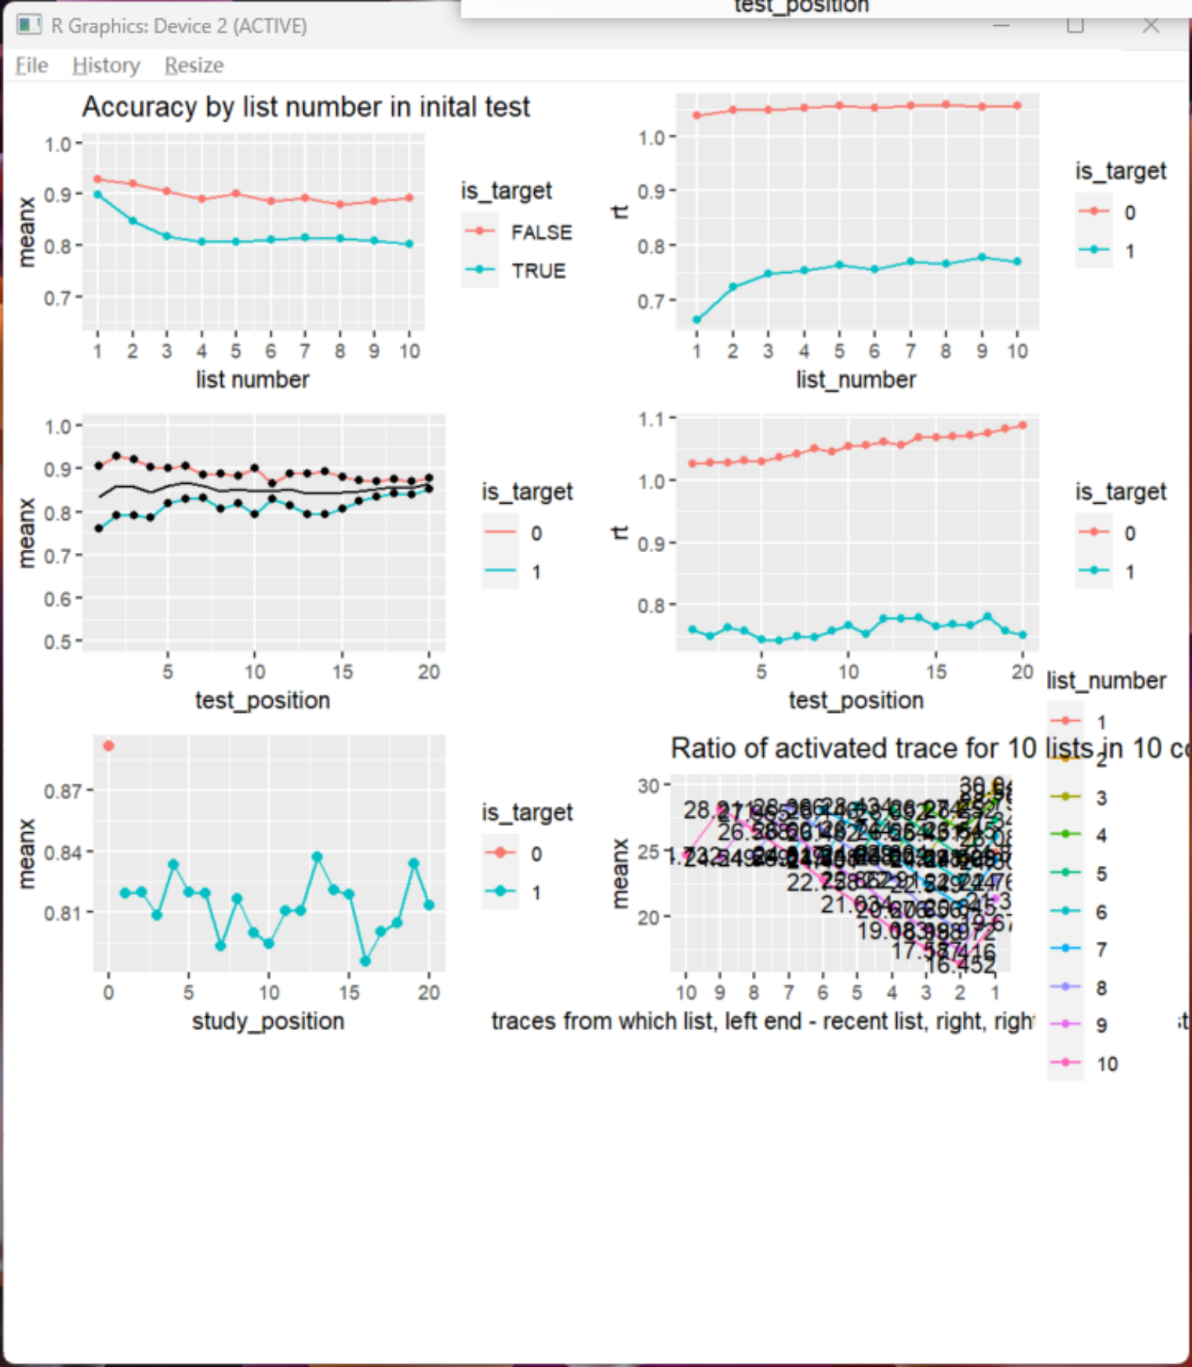

Data:

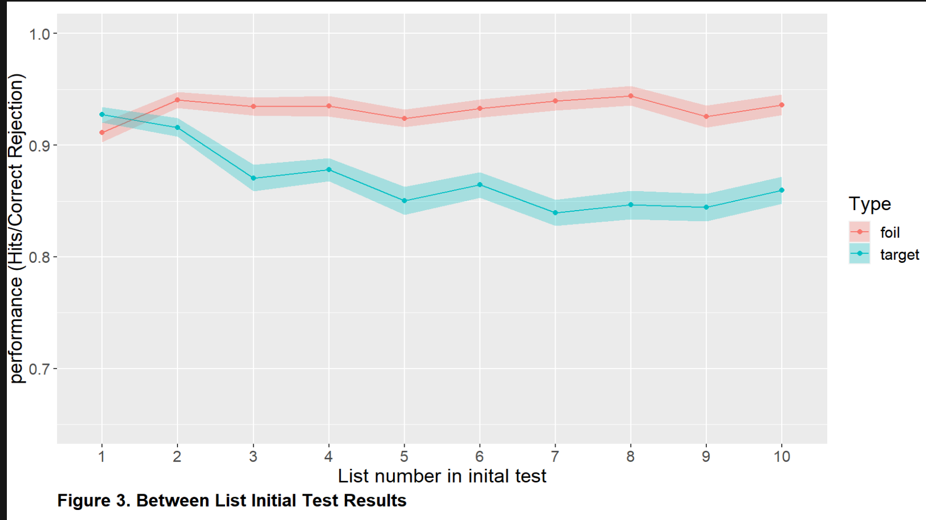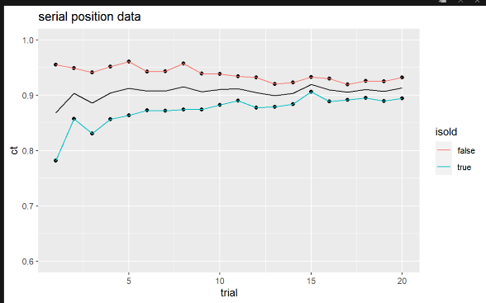

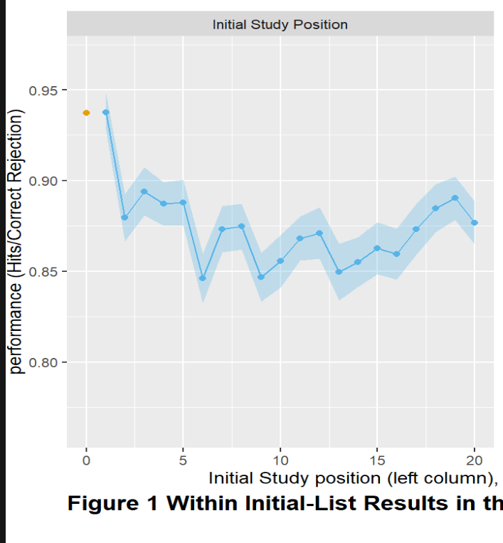

Final Test prediction (criterion 1)

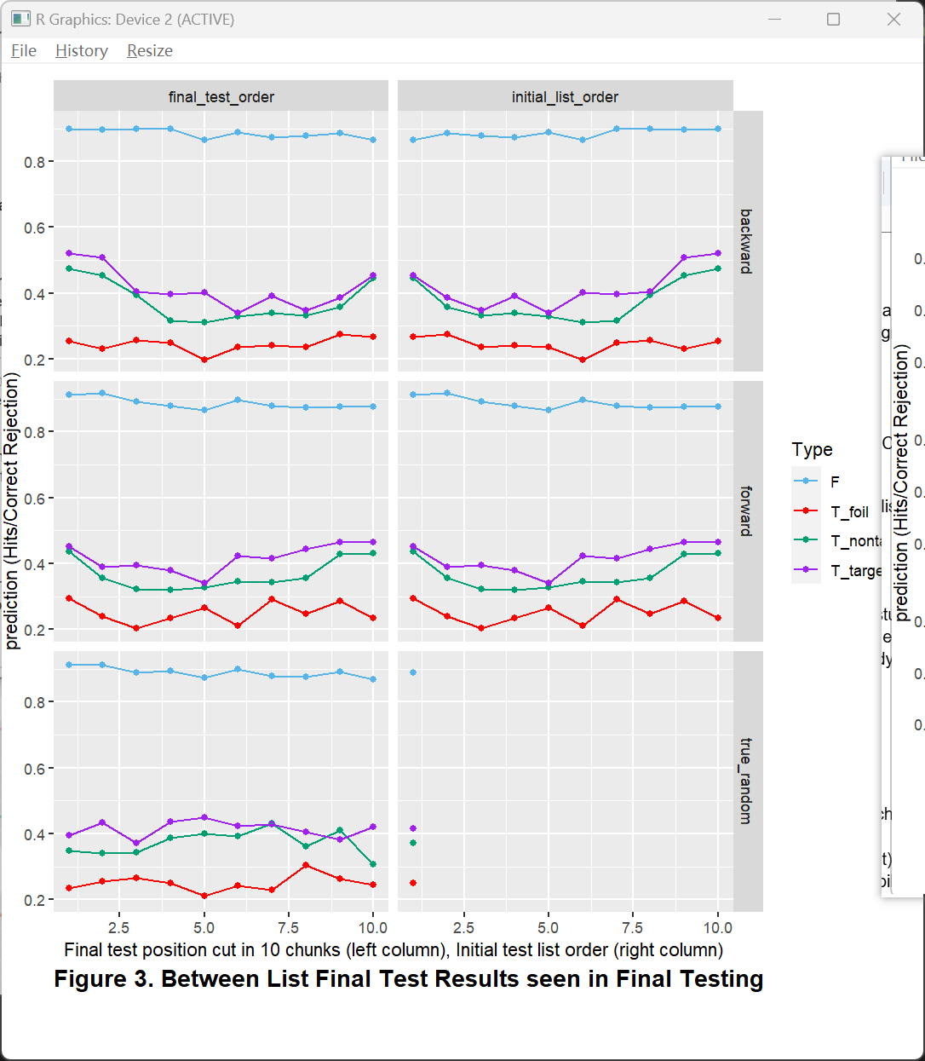

Final Test prediction (criterion 0.2)

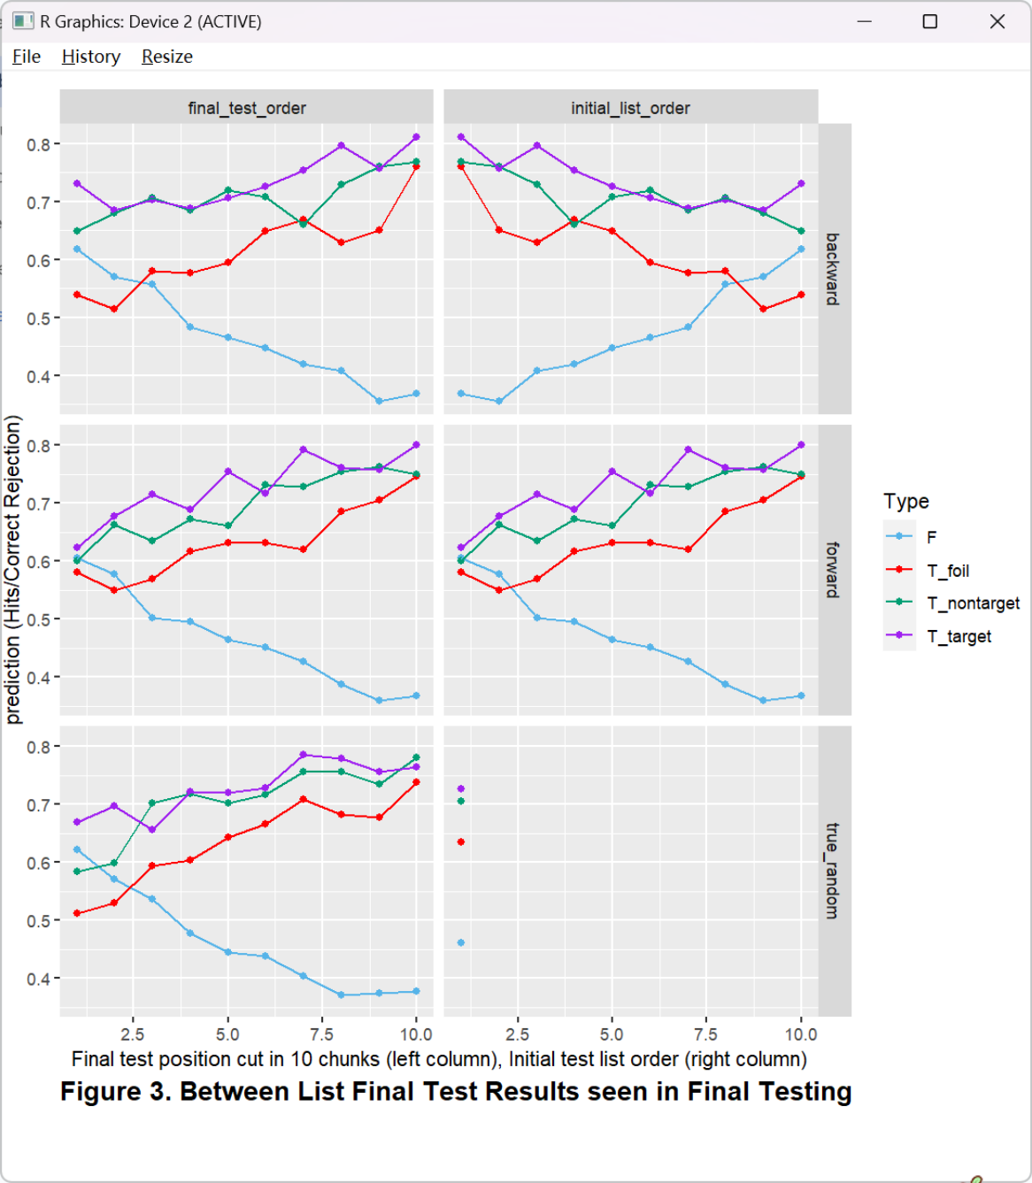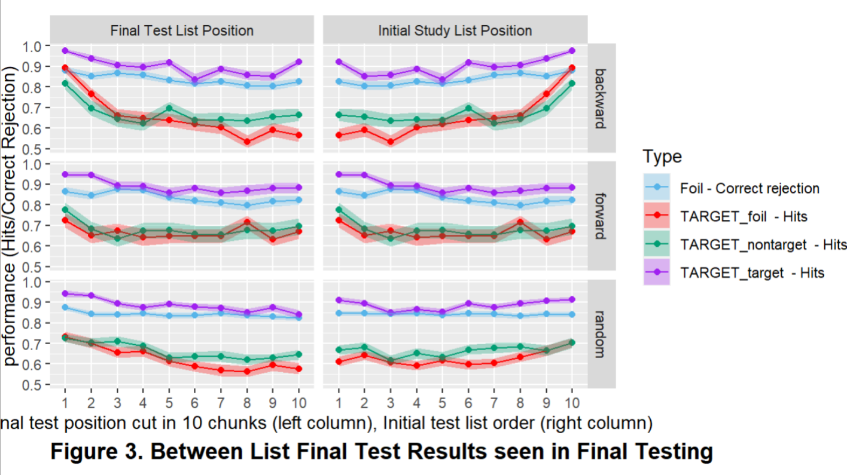

Final Test Data